# CSP554—Big Data Technologies

## Assignment #2

## Ritika Kumari(A20414073)

10. Execute the following hdfs command and take a screen snapshot of the names of the files or directories that are listed (also indicating which is a file and which a directory):

hadoop fs –ls / 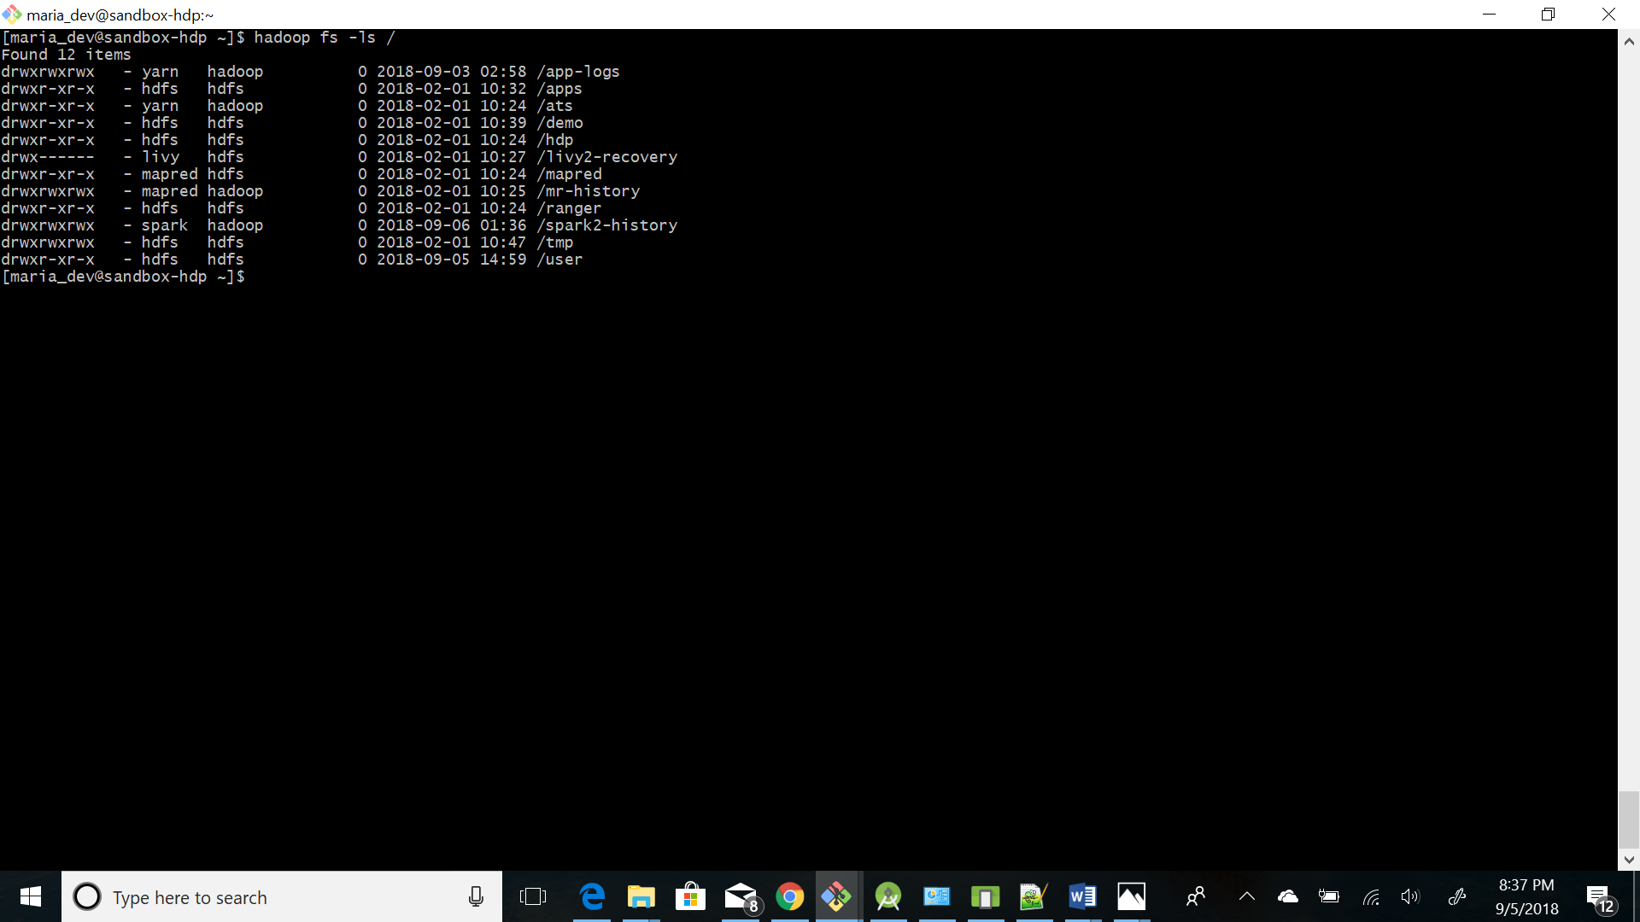

11. Execute a command (you needed to figure out which one) to list the files and directories under the hdfs directory listed below:

/user

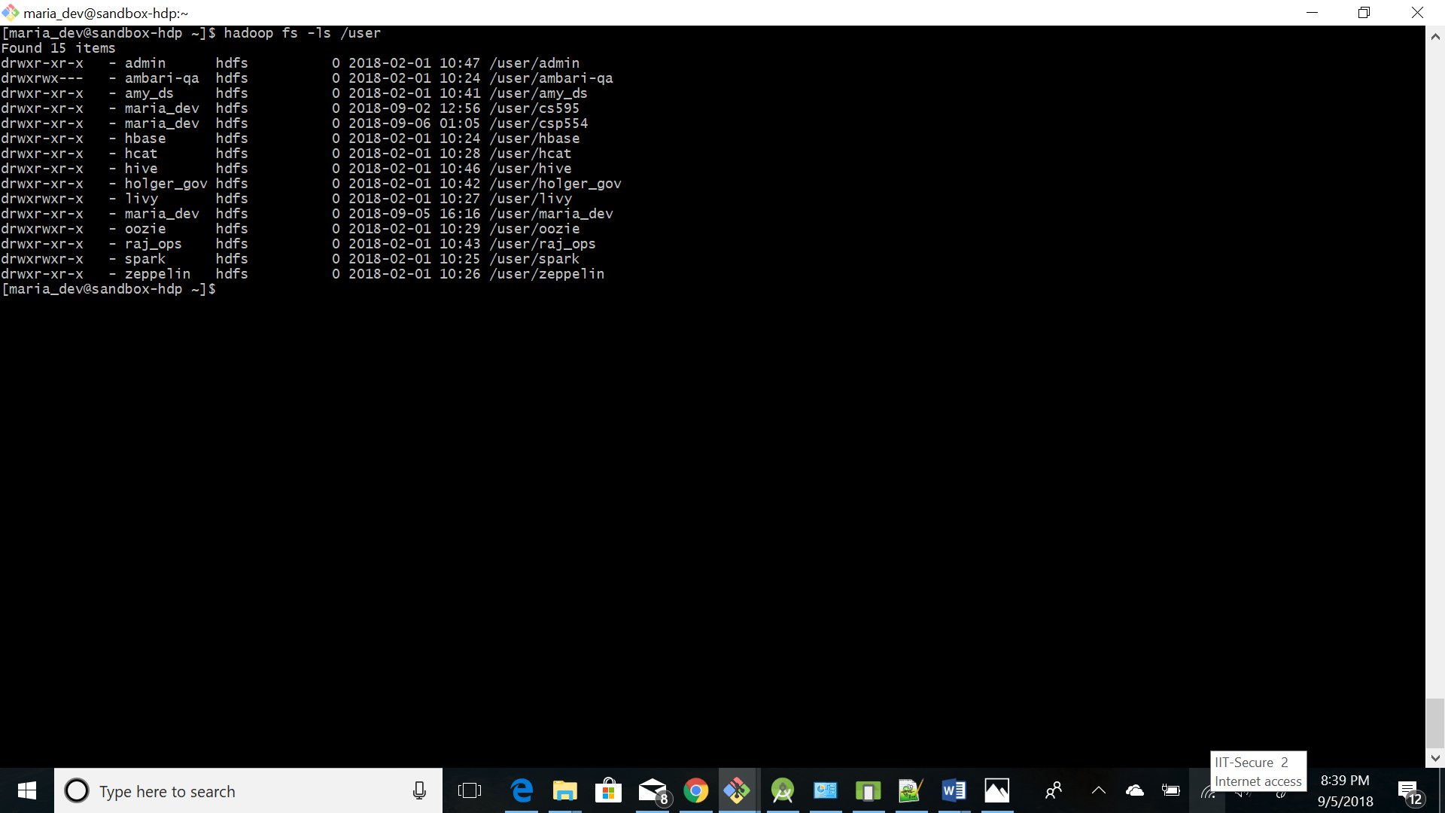

Write down the command you executed and also take a screen snapshot of names of the files or directories that are listed.

**Command:** Hadoop fs -ls /user

12. Execute a command to create the following directory:

/user/csp554/<yournamenospaces>

Note: I created the hdfs directory “/user/csp554” for you already.

Record the command you executed and include it in your assignment submission.

**Command:** hadoop fs -mkdir /user/csp554/RitikaKumari

hadoop fs -ls /user/csp554

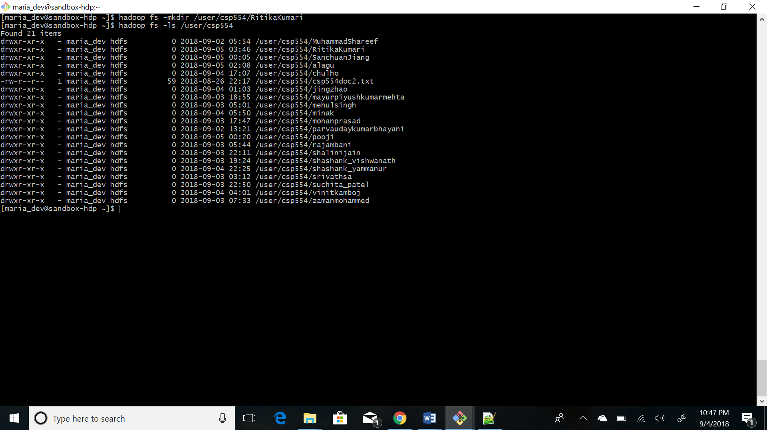

13. Execute a command that copies a given local file (that I already created for you) to the given hdfs directory:

Local file: /home/maria_dev/csp554doc.txt

HDFS directory: /user/csp554/<yournamenospaces>

Record the command you executed and include it in your assignment submission.

**Command:** hadoop fs -put/home/maria_dev/csp554doc.txt /user/csp554/RitikaKumari/

hadoop fs -ls /user/csp554/RitikaKumari

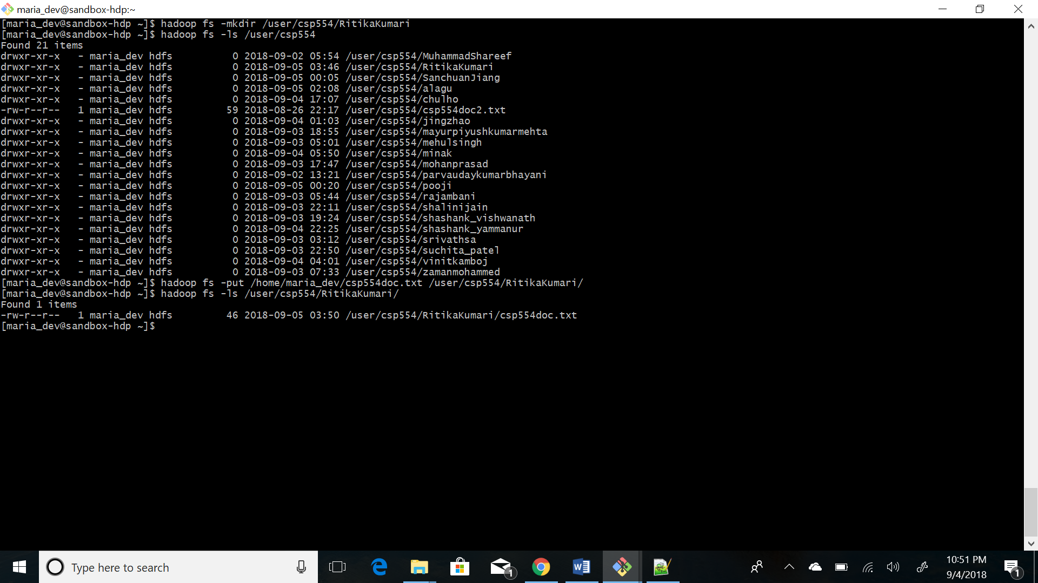

14. Copy the given file from one hdfs directory to another hdfs directory and write down the command

Source hdfs file: /user/csp554/csp554doc2.txt

Note, I created this file for you already

Destination HDFS directory: /user/csp554/<yournamenospaces>

Record the command you executed and include it in your assignment submission.

**Command:** hadoop fs -cp /user/csp554/csp554doc2.txt /user/csp554/RitikaKumari/

hadoop fs -ls / user/csp554/RitikaKumari/

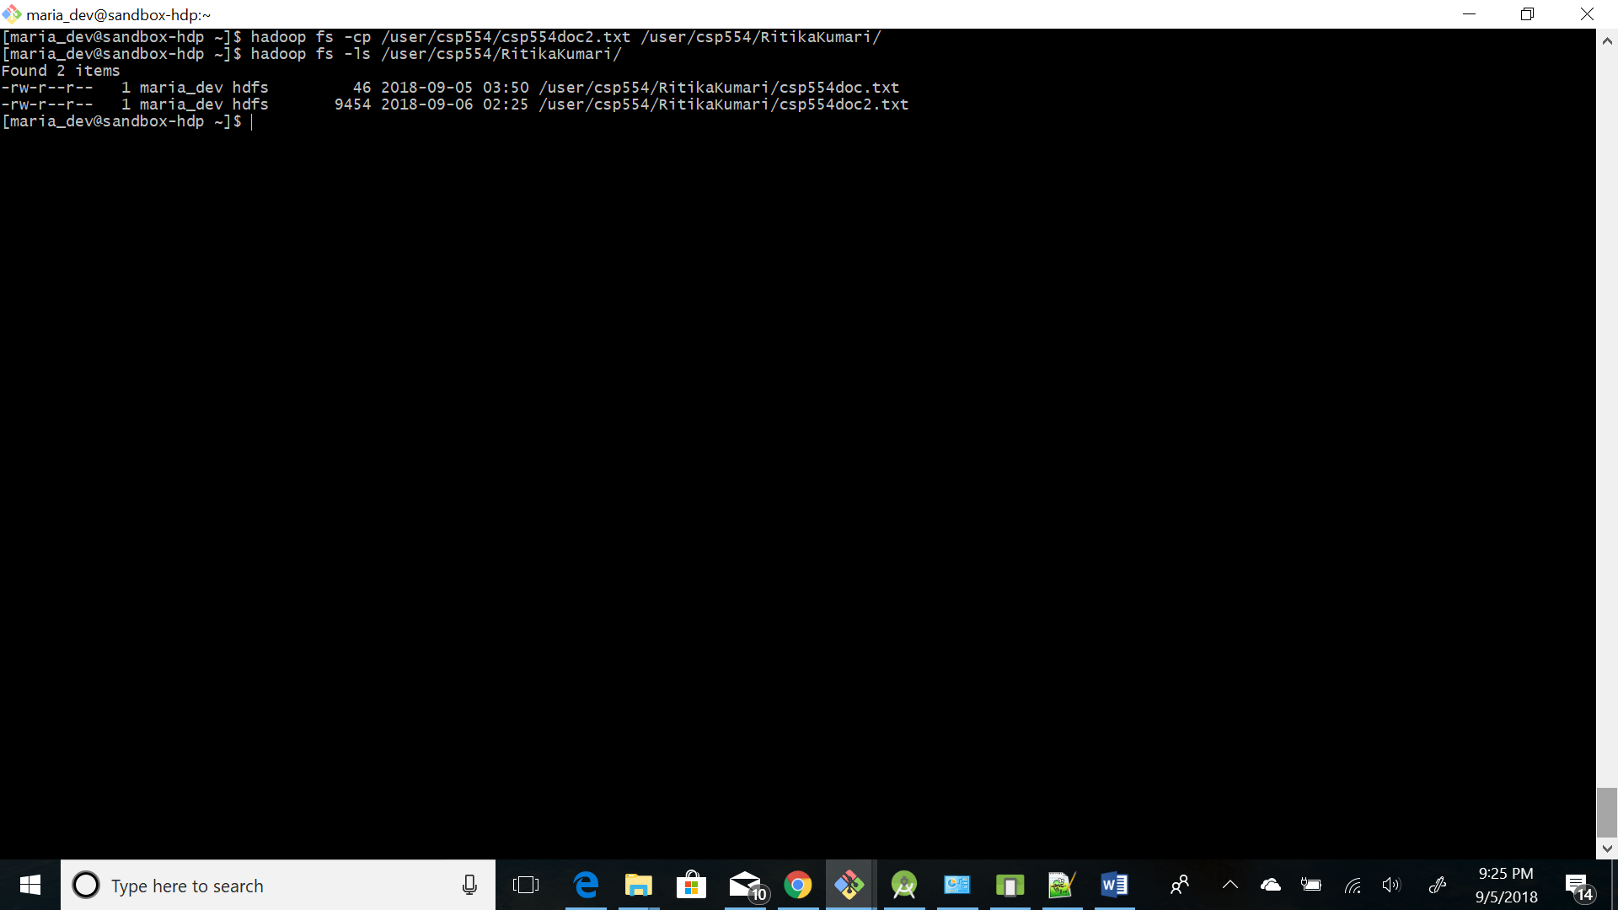

1. This is to get you familiar with the approach to copy files from your MAC or PC to a local account on the Linux machine running the Hadoop Sandbox.

* Create a plain text file on your local machine (PC or MAC). Name it firstname_lastname.txt. The file should hold just one line and that line should hold your first and last name.
* Open a new terminal or bash window
* Copy the local file firstname_lastname.txt to the maria_dev account as follows:
  + scp –P 2222 ./firstname_lastname.txt maria_dev@localhost:/home/maria_dev
  + When prompted for a password, enter
    - maria_dev
  + Note that the “ssh” command used a small p (-p) to specify the port, the scp command uses a capital P (-P) to do so.
* Now, from your hadoop maria_dev account, execute a command that copies the firstname_lastname.txt file to the given hdfs directory :

Local file: /home/maria_dev/firstname_lastname.txt

HDFS directory: /user/csp554/<yournamenospaces>

Record the command you executed and take a screenshot of all files in the directory “/user/csp554/<yournamenospaces>”

**Command:** scp -P 2222 ./Ritika_Kumari.txt maria_dev@localhost:/home/maria_dev

hadoop fs -put /home/maria_dev/Ritika_Kumari.txt /user/csp554/RitikaKumari

hadoop fs -ls /user/csp554/RitikaKumari

